Effective February 17, 2020, IdentoGO by IDEMIA (formerly MorphoTrust), changed from using the Process Control Number (PCN) to using a Transaction Control Number (TCN) *and* a Universal Enrollment Identification Number (**UEID**).

The IdentoGO receipt will no longer display the applicant’s PCN or TCN, but will instead display the applicant’s **UEID**. The UEID is 10 characters long and will have the prefix of “UZNJ” for New Jersey submissions. The remaining 6 characters will be alpha or numeric, randomly assigned by the system.

Agencies can retrieve applicant’s TCN by entering the applicant’s UEID number *and* DOB on the IdentoGO website [https://uenroll.IdentoGO.com/](https://uenroll.identogo.com/).

Once you have retrieved the TCN enter the following information on the Fingerprint Approval Retrieval Application (**FARA**) website <https://fara.dhs.state.nj.us> (Microsoft Edge *web browser is required*) to access the applicant’s results:

* Applicant’s TCN
* Agency’s Contributor Case Number
* Date the applicant was fingerprinted

***Note:***

* *Applicants will need to retain their IdentoGO receipt.*
* *Applicants will need to provide their IdentoGO receipt to their Agency.*
* *Agencies will need to retain the applicant’s TCN for archiving or other purposes.*
* *Agencies are required to look up the applicant’s TCN on the IdentoGO website.*
* *The Employment Control and Compliance Unit (ECCU) cannot provide an applicant’s TCN to agencies or applicants.*
* *Fingerprint applicants are not authorized to access results from FARA, only agency personnel should access results from FARA.*

If you need assistance, please send an email to the FARA Helpdesk at [ECCU.FARA@dhs.nj.gov](mailto:ECCU.FARA@dhs.nj.gov).

See the illustration below for retrieving applicant’s TCN.

***IdentoGO receipt with UEID number.***

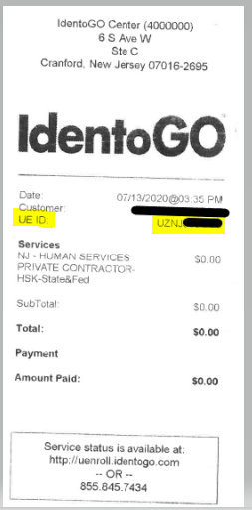

***Visit IdentoGO’s website*** [***https://uenroll.IdentoGO.com***](https://uenroll.identogo.com)

Click on “***Check the Status of your Service.***”

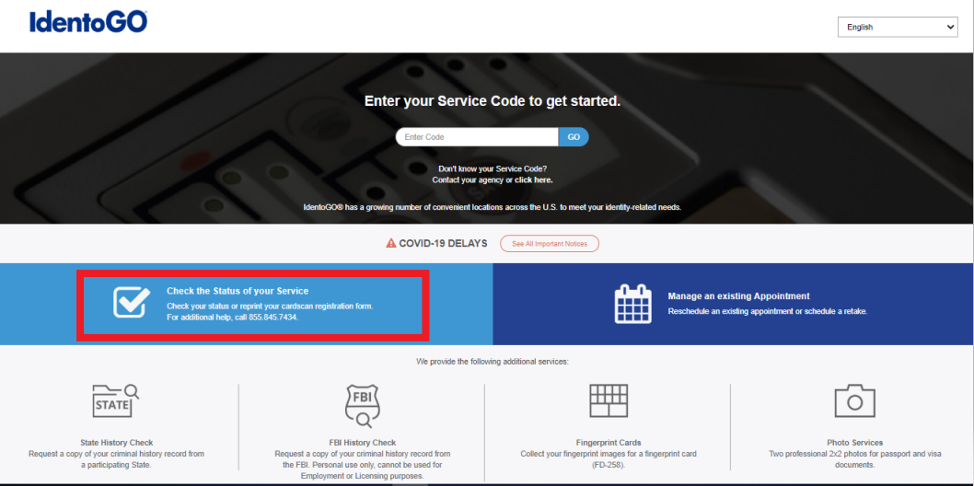

***Enter the applicant’s UEID and DOB.***

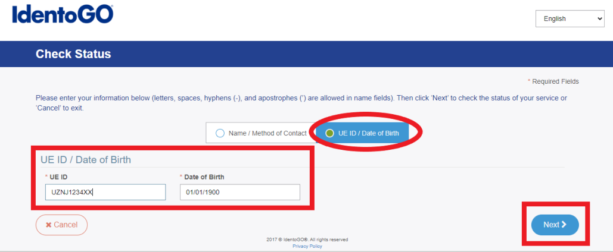

***The Service Summary page list the applicant’s TCN which starts with the numbers 4966.***

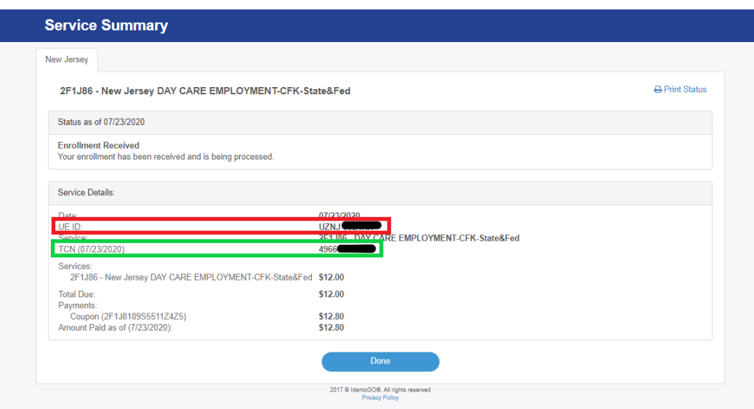

***Visit FARA website***[*https://fara.dhs.state.nj.us*](https://fara.dhs.state.nj.us)***(Microsoft Edge web browser is required).***

***Enter the Applicant’s TCN, Agency’s Contributor Case Number and Date the applicant was fingerprinted. Click Submit. The Search Results will display below and then Click ‘Print Letter.’***

